ECT286 Final Project Report

PLC Conveyor Belt

*Utilizing LogixPro building a PLC Conveyor Belt to fill twelve boxes.*

Taylor Muse   
Engineering Technology

ECT286

Professor: Mohamed Brihoum

DeVry University

College of Engineering and Information Sciences



2024

Executive Summary

This report will cover my final project for ECT286 Automation and control, in this class I have learned how to apply the fundamentals of Programmable Logic Controllers (PLC’s), an array of sensors as well as the logic circuitry that make up the backbone of operation for these devices. You will see in this report how I created a logic ladder, which is a design tool for testing PLC designs and incorporate the sensors that are desired for the production piece. You will also see the silo simulator from Logix Pro that will conduct the process that is shown in the ladder logic. The goal of this system was to automate a conveyor belt to move boxes under a silo that has a proximity sensor, a solenoid valve and an overflow sensor. The boxes will be filled and then moved to a storage bin until twelve boxes have been filled. The overflow sensor will shut down the system if a box overflows. To reset the process after an overflow you must re-download the program and reset the simulation which is like a hard reboot. This I see as a flaw in the program that in reflection I would create a work around so that the system can reset without re-downloading the program. *Table 1* will show all the inputs and outputs used in the ladder logic and you also find, in *Figure 3,*  a video that shows the operation running and a brief audio overview of how to operate the program.

Table of Contents

Introduction 1

Project Description 1

Project Objectives 1

List of Material 1

Project Design 1

Test Results 1

Lessons Learned 2

Author's Biography 2

Works Cited 2

Work Consulted 2

Appendix A 2

Appendix B 2

Introduction

This report has been generated to present my knowledge in automation and control design. Specifically, I will showcase the generation of a programmable logic control logic ladder (PLC) and explain the effects that each step will have on the desired outcome.

# Project Description

To thoroughly demonstrate the execution of this task I used the LogixPro software that enables users to create logic diagrams and see how they function in respect to the many simulators that are available in the application. The example I have used to facilitate this demonstration is a PLC that controls a conveyor belt to move boxes under a filling solenoid and runs on a timer to fill the box then move a new box under the filling solenoid until 12 boxes have been filled and moved off the belt.

# Project Objectives

In this report you will see how I used the silo simulator on LogixPro which has built in start and stop switches as well as the conveyor motor and proximity switch. When the program is running a light next to the “Run” section in the top left box of the simulator will flash because it is operating on a clock status bit. After the program is placed in “Run” the conveyor will move the box until a box is detected by the proximity sensor under the fill solenoid. After the box is detected and the conveyor has stopped a timer will run while the solenoid opens the valve to fill the box. At the completion of the timer, the conveyor will turn on again moving the box from the conveyor and a new box will be moved under the fill solenoid. Each time the fill solenoid is turned on a counter will advance one unit until it reaches twelve, at which point the program will stop the operation. As a check placed in the system there is also an overflow sensor that will automatically shut down the system if it senses that a box has overflowed. This will require the program to be reset and started over.

# List of Material

TLP LogixPro Simulator.

# Project Design

Below you will find pictures of the simulator in run and the ladder logic table for how this goal was achieved. *Figure 1* (below) shows the silo simulator, *Figure 2 (below)* shows the ladder logic diagram and *Table 1* (below) is a list of all inputs and outputs used in the ladder logic.

Figure 1

In the top left beige box are the “RUN,” “FILL” and “FULL” indicator lights. “RUN” will be flashing when the operation is running, “FILL” will light when the solenoid valve is open, and “FULL” will be lit when the box has overflowed. Below the indicators are the switches to operate the simulator, “START,” “STOP,” and “A/B/C.” “Start” is a normally open (NO) momentary switch that will apply power to the system if there is not an overflow detected and the counter has not reached twelve. “Stop” is a NO momentary switch that will remove power from the system until “Start” is pressed again. The “A/B/C” rotary switch is used to reset the counter logic back to zero by placing it in position “B.” Under the silo there is a normally closed (NC) solenoid valve that opens when the proximity sensor under the conveyor belt detects the presence of a box, in turn, filling the box for a predetermined amount of time. On the right side of the fill port of the silo there is a level sensor that detects if the box has begun to overflow. This sensor, represented as an examine if open switch, will shut down the program stopping all parts if it detects the box has overflowed. And finally at the bottom of the conveyor belt on the right side is the motor which is running when the system is powered on, and the solenoid valve is not open.

Figure 2

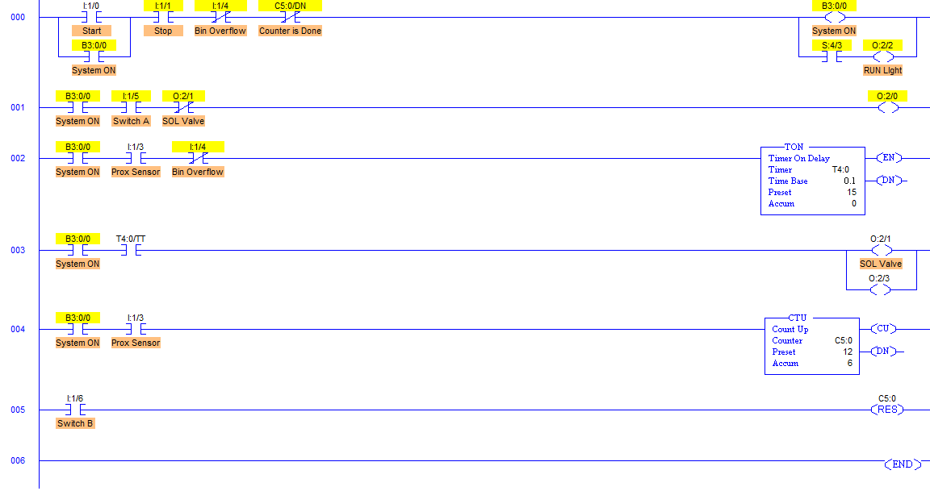

Ladder logic design layout:

Rung 000 holds the master logic for starting and stopping the process, the start input I:1/0 turns on system power B3:0/0, and the process will stop if an overflow is detected at I:1/4 or when the counter reaches 12 at C5:0/DN which presents a signal when the counter has reached the preset number.

Rung 001 controls the conveyor operation, the conveyor belt will move when the system power is on, the rotary switch A/B/C Is in the A position and the solenoid valve is not open.

Rung 002 controls the timer for the fill solenoid. The Fill solenoid will open with system power on, a box is detected by the proximity sensor I:1/3 and an overflow condition are not present at I:1/4.

Rung 003 starts the timer, opens the solenoid valve, and activates the “FILL” light.

Rung 004 counts t times the proximity sensor detects a box under the fill solenoid and stops the process when it reaches twelve.

Rung 005 resets the counter by moving the rotary switch to the “B” position.

Table 1

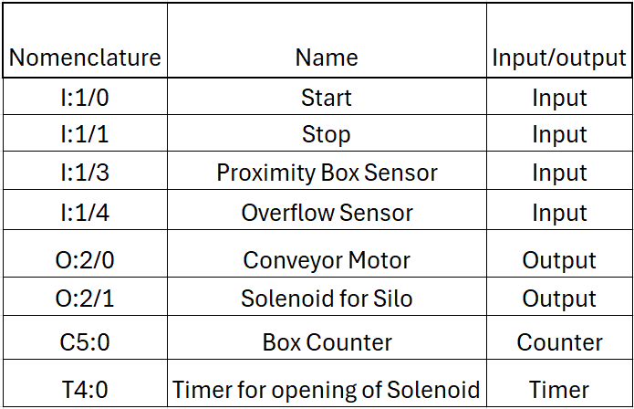

*Table 1 (*above) is a list of all the input and outputs used in the ladder logic diagram for this project.

# Test Results

*Figure 3* is a video demonstrating the successful test of the conveyor belt operation with audio of my explanation of the process. Double-click on the video to view the video with a voiceover explanation of the process.

Figure 3



# Lessons Learned

Upon reflection on this project, I would have added another rung that allows the overflow sensor to be reset without downloading the program again and resetting the simulation. The way it is currently configured the overflow sensor acts as an emergency stop, which requires the entire program to be turned off before operating again.

# Author's Biography

I have served in the US Navy for 10 years working on advanced electronics, including radar systems, missile directors and multiple automated machines. My experience with PLC’s started from my first year of training when we were taught how to troubleshoot circuit boards using a NIDA board that will simulate faults based on the specific tests at hand. However, I was not aware exactly how PLCs functioned until this class where we received first-hand experience in designing the functionality of the PLC and learned how all the different types of sensors can be used for the PLC to perform a task without input of the operator. Now that I have begun my collegiate excursion, I hope to gain experience in the network and automation field to support the career experience so that I can venture into the world of machine learning and cloud networking.

# Works Cited

[1] Bartelt, T. (2011). Industrial Automated Systems: Instrumentation and Motion Control. Clifton Park, NY: Delmar, Cengage Learning.

[2] Setting the Standard in PLC Hands-on Training. (n.d.). Retrieved from The Learning Pit: <https://canadu.com/lp/logixpro.html>

[3] LogixPro The Silo Lab Utilizing Relay Logic. (n.d.). Retrieved from The Learning Pit: <https://canadu.com/lp/doc/sl/sl-rl.html>

# Work Consulted

Winter Taylor, Devry University

Rodrick Flowers, Devry University

# Appendix A

No Datasheet to provide.

# Appendix B

I offered as feedback to my classmates to ensure proper execution of this project, to keep note of references used during the research of different sensor types and their uses. I also offered to keep an open mind to the many uses that a PLC can have in today’s world. From automated robotics performing surgery, to a coffee machine that needs no input from the user other than adding coffee beans to the tank.